Htno:2403A51349
Batch:14
Assignment 4.2
Task Description#1
- Zero-shot: Prompt AI with only the instruction — Write a Python function to generate the Fibon acci sequence up to n terms acci sequence up to n terms

- 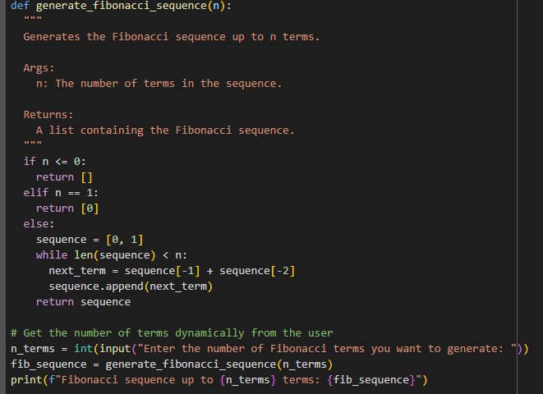
Output:

Task Description#2
- One-shot: Provide one example: Input: 100, Output: 37.78 to help AI generate a function that converts Fahrenheit to Celsius.

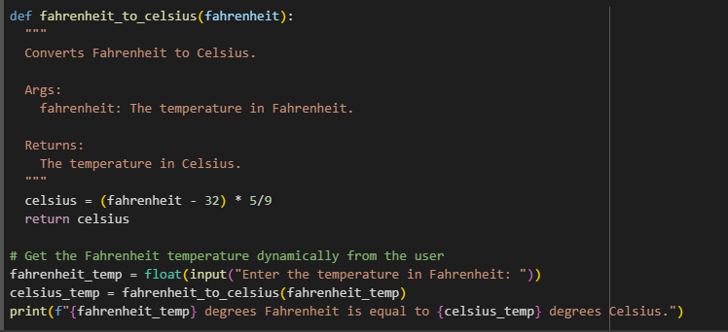
Output:

Task Description#3
- Few-shot: Give 2–3 examples to create a function that extracts the domain name from an email address.
1.
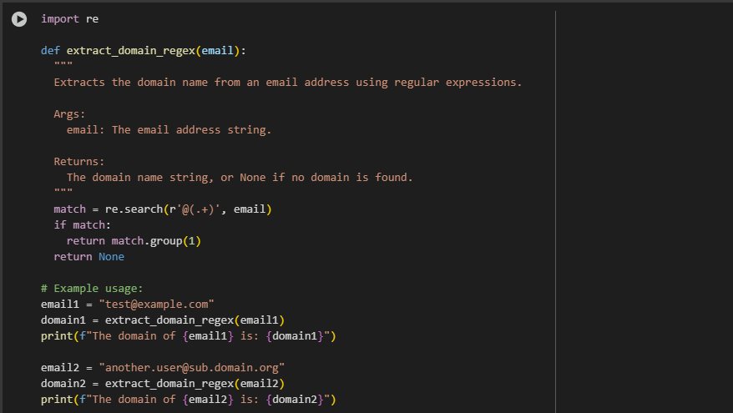
Output:
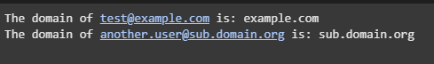
2.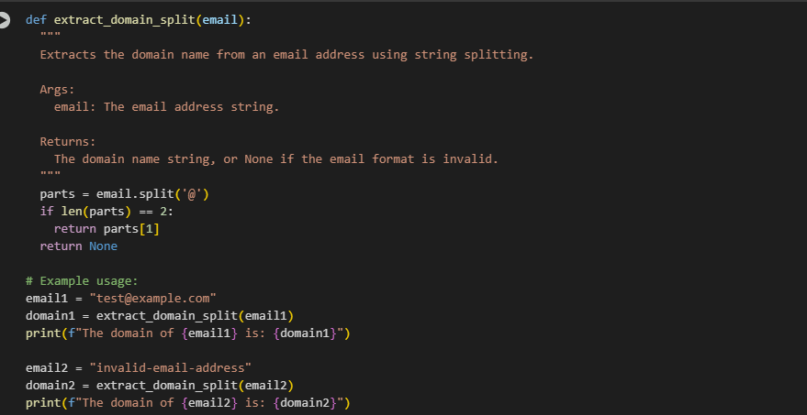
Output:
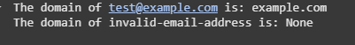

Task Description#4
- Compare zero-shot vs few-shot prompting for generating a function that checks whether a word is a palindrome, ignoring punctuation and case.

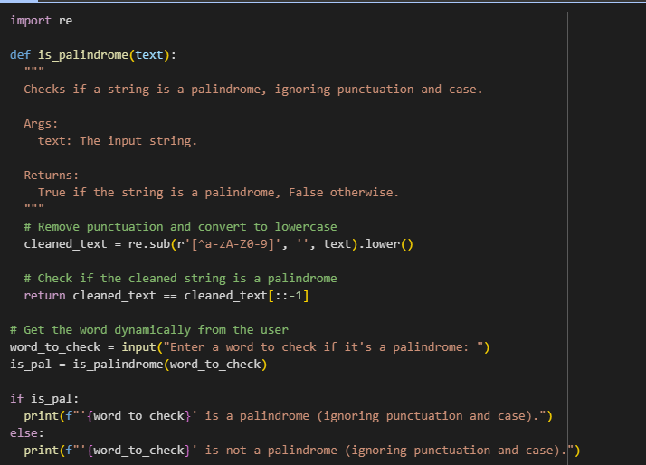
Output:

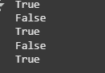

- Use few-shot prompting with 3 sample inputs to generate a function that determines the maximum of three numbers without using the built-in max() function.
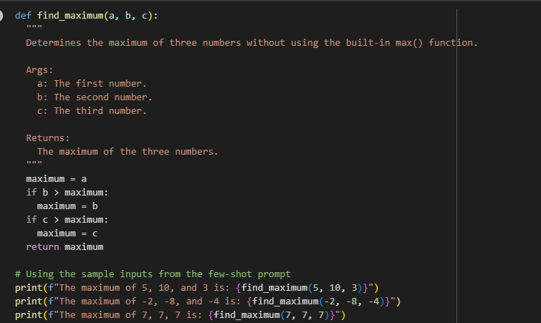

Output:

